**VAISHALI BOKADIYA**

**PYTHON CODING CHALLANGE**

**QUESTION 2**

**Execute with one example Lambda Functions in Python**

Lambda Functions or Lambda Expressions are the anonymous functions. They work exactly the same as the functions created using def keyword. Lambda functions are used for single line functions.

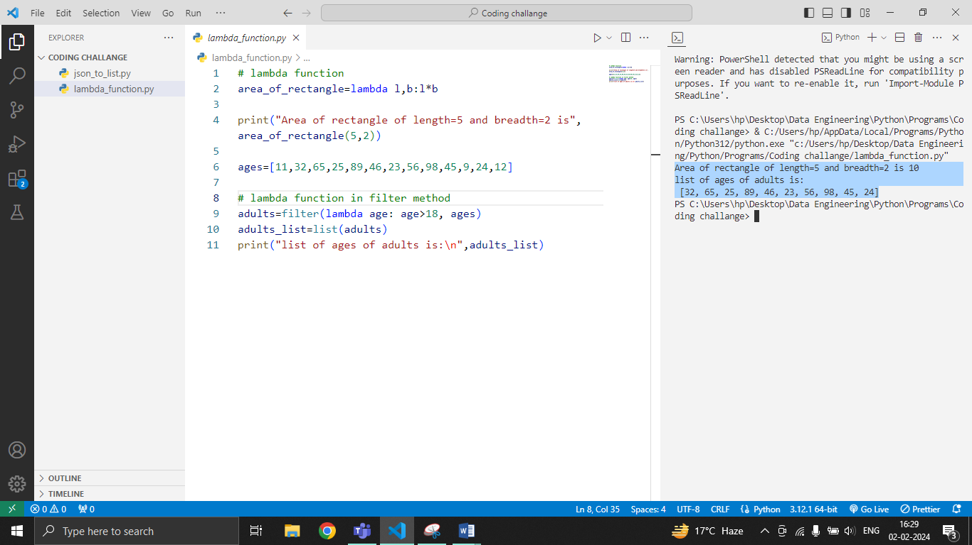

**Read JSON Strings to Python dicts or lists**

JSON strings can be read into python dicts or lists using the json.loads() method. It converts json string into python object/list. It takes an argument ie. the json string and returns python object.

